US History In-Class DBQ #1: English Colonies, North and South

Historical Context: The sixteenth-century English intellect had plenty of fare for imaginative rumination. Sir Thomas More’s Utopia, translated into English in 1551, beckoned with its perfect society in Paradise, a small island somewhere in the New World. Richard Hakluyt interviewed many of the sailors and adventurers to those new lands and his edited travelogues of the 1580’s sparked expectations of wealth and plunder beyond anyone’s dreams. Even William Shakespeare contributed to this romantic geography with the captivating beauty of Prospero’s island in The Tempest.
The fantasy of far-away visions had a particular appeal to the residents of a troubled, turbulent England. The British Isles (and most of Europe) had rebounded from the catastrophic social and economic effects of the Black Death two centuries earlier and land was at a population-boom premium. Increased prosperity brought increased trade, and worldwide mercantile networks and commercial expansion were underway. A primary English contribution to this new market system was wool, a commodity that made the conversion of formerly open feudal farmlands to the enclosed pasture profitable. Displaced peasants left the countryside and moved to major cities like London in search of livelihood, and the ranks of the urban poor swelled.
Also in the sixteenth century, Henry VIII broke his country’s ties with the Catholic Church and established the Church of England with himself as head. Although this English chapter of the Protestant Reformation had more to do with dynastic succession and Henry’s hope for a son than theological dispute, his actions nonetheless loosed religious dissent and sectarianism in his kingdom. The eventual ascension of his Catholic daughter, Mary, re-established Catholicism in England for a time until Elizabeth I severed ties with Rome a second time in 1558 and rekindled religious differences anew.
Social, economic, and religious disjunctions pried up a population from its old traditions and ties. When the time for English settlement of North America came, there was no shortage of candidates. Some came for wealth and some came for adventure. Some fled poverty while some others fled religious discrimination and persecution. Their reasons for immigration were as different as the new lands they claimed and the communities they founded. What precious little they shared in common, beyond English origins, was the fragile hope of a better life in a better world. They were, as Captain John Smith of Jamestown tells us, people with “great spirit, but small means.”

Directions: The following essay question is based on the accompanying documents in Part A. As you analyze the documents, take into account both the source of the document and the author’s point of view.

Be sure to:
- Carefully read the document based question.
  - Consider what you already know about the topic
  - How would you answer the question if you had no documents to examine?
- Now, read each document carefully, underlining key phrases and words that address the document based question.
  - You may also wish to use the margin of your paper for notes
  - Answer the questions that follow each document
- Based on your knowledge of the topic and on the information found in the documents, formulate a thesis that directly answers the question.
- Organize supportive and relevant information using the attached 5 paragraph outline worksheet.
  - Completely write out your thesis statement in the appropriate place
  - Completely write out each paragraph topic sentence
  - The outline should be able to prove your thesis
  - The information in the outline should be logically presented
  - The outline should include both information from the documents and from your outside knowledge of the subject

Terms and concepts that do not appear in the documents but could be used in the final essay:

Native Americans Virginia’s headright system Scots-Irish frontiersmen
Maryland Catholic Haven Plantations Enclosure movement
Farming, fishing, lumber, shipping Dutch in New York Religious persecution
Spanish and French threats Lord Baltimore Protestant Reformation
Indentured servants Pennsylvania “Dutch” Patroon plan
James Oglethorpe Tobacco English Civil War
Calvinism Roger Williams Quakers

Essay Question: Although New England and the Chesapeake region were both settled largely by people of English origin, by 1700 the regions had evolved into two distinct societies. Why did this difference in development occur? Use the documents AND your knowledge of the colonial period up to 1700 to develop your answer.

Part A: Document Analysis
Document 1

Source: John Winthrop, A Model of Christian Charity (Written aboard the Arbella on the Atlantic Ocean, 1630)

God Almighty in his most holy and wise providence hath so disposed of the condition of mankind, (that) in all times some must be rich, some poor, some high and eminent in power and dignity, other mean and in subjection….(Yet) we must be knit together in this work as one man. We must entertain each other in brotherly affection, we must be willing to abridge ourselves of our superfluities for the supply of others’ necessities. We must uphold a familiar commerce together in all meekness, gentleness, patience, and liberality. We must delight in each other, make others’ conditions our own, rejoice together, mourn together, labor and suffer together, always having before our eyes our commission and community in the work, our community as members of the same body. So shall we keep the unity of the spirit in the bond of peace…..We must consider that we shall be as a city upon a hill. The eyes of all people are upon us, so that if we shall deal falsely with our God in this work we have undertaken, and so cause him to withdraw his present help from us, we shall be made a story and a by-word through the world. We shall open the mouths of enemies to speak evil of the ways of God,….shall shame the faces of many of God’s worthy servants, and cause their prayers to be turned into curses upon us.

What type of source is this? (Primary or secondary and WHAT is it?) _________________________________
__________________________________________________________________________________________
What is Winthrop’s overall message in this sermon? _______________________________________________
__________________________________________________________________________________________
__________________________________________________________________________________________
What argument does he use to convince his listeners? ______________________________________________
__________________________________________________________________________________________
__________________________________________________________________________________________

Document 2

Source: Historical Society of Southern England.

Ship’s List of Emigrants Bound for New England.
John Porter, Deputy Clerk to Edward Thoroughgood
Weymouth, England. 20th of March, 1635

1. Joseph Hull, of Somerset, a minister, aged 40 years  2. Agnes Hull, his wife, aged 25 years  3. Joan Hull, his daughter, aged 15 years  4. Joseph Hull, his son, aged 13 years  5. Tristram, his son, aged 11 years  6. Elizabeth Hull, his daughter, aged 7 years  7. Temperance, his daughter, aged 3 years  8. Grissel Hull, his daughter, aged 3 years  9. Dorothy Hull, his daughter, aged 3 years  10. Judith French, his servant, aged 20 years  11. John Wood, his servant, aged 20 years  12. Robert Dabyn, his servant, aged 28 years  13. Musachiell Bernard, of Batcombe, clothier in the county of Somerset, aged 24 years  14. Mary Bernard, his wife, aged 28 years  15. John Bernard, his son, aged 3 years  16. Nathaniel, his son, aged 1 year  ***********************  21. Timothy Tabor, in Someret of Batcombe, tailor, aged 35 years  22. Jane Tabor, his wife, aged 35 years  23. Jane Tabor, his daughter, aged 10 years  24. Anne Tabor, his daughter, aged 8 years  25. Sarah Tabor, his daughter, aged 5 years  26. William Fever, his servant, aged 20 years | 27. John Whitmarke, aged 39 years  28. Alice Whitmarke, his wife, aged 35 years  29. James Whitmarke, his son, aged 5 years  30. Jane, his daughter, aged 7 years  31. Onseph Whitmarke, his son, aged 5 years  32. Rich Whitmarke, his son, aged 2 years  ***********************  74. Robert Lovell, husbandman, aged 40 years  75. Elizabeth Lovell, his wife, aged 35 years  76. Zacheus Lovell, his son, aged 15 years  77. Anne Lovell, his daughter, aged 16 years  78. John Lovell, his son, aged 15 years  79. Ellyn, his daughter, aged 1 year  80. James, his son, aged 1 year  81. Joseph Chickin, his servant, 16 years  82. Alice Kinham, aged 22 years  83. Angell Hollard, aged 21 years  84. Katheryn, his wife, 22 years  85. George Land, his servant, 22 years  86. Sarah Land, his kinswoman, 18 years  103. John Hoble, husbandman, 13  104. Robert Huste, husbandman, 40….

What type of source is this? (Primary or secondary and WHAT is it?) _________________________________
__________________________________________________________________________________________
What overall observations may be made about this list of immigrants? _________________________________
__________________________________________________________________________________________
__________________________________________________________________________________________
__________________________________________________________________________________________
__________________________________________________________________________________________

Document 3

Source: Historical Society of Southern England. Ship’s list of immigrants bound for Virginia

July 30, 1635

These underwritten names are to be transported to Virginia, embarked in the ship Merchant’s Hope, Hugh Weston, Master, per examination by the minister of Gravesend touching their conformity to the Church discipline of England, and have taken the oaths of allegiance and supremacy.

Edward Towers 26  Henry Woodman 22  Richard Seems 26  Vyncent Whatter 17  James Whithedd 14  Jonas Watts 21  Peter Loe 22  Geo. Brocker 17  Henry Eeles 26  Jo. Dennis 22  Tho. Swayne 23  Charles Rinsden 27  Jo. Exston 17  Wm. Luck 14  Jo. Thomas 19  Jo. Archer 21  Richard Williams 25  Francis Hutton 20  Savill Gascoyne 29  Rich. Bulfell 29  Rich. Jones 26  Toh. Wynes 30  Humphrey Williams 22  Edward Roberts 20  Martin Atkinson 32  Edward Atkinson 28  Wm. Edwards 30 | Nathan Braddock 31  Jeffrey Gurrish 23  Henry Carrell 16  Tho. Tyle 24  Gamaliel White 24  Richard Marks 19  Tho. Clver 16  Jo. Kitchin 16  Edmond Edwards 20  Lewes Miles 19  Jo. Kennedy 20  Sam Jackson 24  Allin King 19  Rowland Sadler 19  Jo. Phillips 28  Daniel Endick 16  Jo. Chalk 25  Jo. Vynall 20  Edward Smith 20  Jo. Rowlidge 19  Wm. Westlie 40  Jo. Smith 18  Jo. Saunders 22  Tho. Barcherd 16  Tho. Dodderidge 19  Richard Williams 18  Jo. Balance 19 | Wm. Baldin 21  Wm. Pen 26  Jo. Gerie 24  Henry Baylie 18  Rich. Anderson 50  Robert Kelum 51  Richard Fanshaw 22  Tho. Bradford 40  Wm. Spencer 16  Marmaduke Ella 22  Women  Ann Swayne 22  Eliz. Cote 22  Ann Rice 23  Kat. Wilson 23  Maudlin Lloyd 24  Mabell Busher 14  Annis Hopkins 24  Ann Mason 24  Bridget Crompe 18  Mary Hawkes 19  Ellin Hawkes 18

What type of source is this? (Primary or secondary and WHAT is it?) _________________________________
__________________________________________________________________________________________
What overall observations may be made about this list of immigrants? _________________________________
__________________________________________________________________________________________
__________________________________________________________________________________________
__________________________________________________________________________________________
__________________________________________________________________________________________

How does this list compare to the list in Document #2
__________________________________________________________________________________________
__________________________________________________________________________________________
__________________________________________________________________________________________
__________________________________________________________________________________________
Document 4

Source: Articles of Agreement, Springfield, Massachusetts, 1636

We whose names are underwritten, being by God’s providence engaged together to make a plantation….do mutually agree to certain articles and orders to be observed and kept by us and by our successors…

- We intend by God’s grace, as soon as we can, with all convenient speed, to procure some Godly and faithful minister with whom we purpose to join in church covenant to walk in all the ways of Christ.
- We intend that our town shall be composed of forty families…..rich and poor.
- That every inhabitant shall have a convenient proportion for a house lot, as we shall see (fit) for everyone’s quality and estate…..
- That everyone shall have a share of the meadow or planting ground….

What type of source is this? (Primary or secondary and WHAT is it?) _________________________________
__________________________________________________________________________________________
What is the overall goal of this document? _______________________________________________________
__________________________________________________________________________________________
__________________________________________________________________________________________
What kind of society do these writers hope to create in Springfield, Massachusetts? ______________________
__________________________________________________________________________________________
__________________________________________________________________________________________
Document 5

Source: An Ordinance for Wage and Price Regulations in Connecticut, 1676

Whereas a great cry of oppression is heard among us, and that principally pointed at workmen and traders, which is hard to regulate without a standard for pay, it is therefore ordered that….(prices and wages) be duly set at each of our General Courts annually…All breaches of this order to be punished proportional to the value of the oppression…This court….in the interim recommends (that) all tradesmen and laborers consider the religious end of their callings, which is that receiving such moderate profit as may enable them to serve God and their neighbors with their arts and trades comfortably, they do not enrich themselves suddenly and inordinately by oppressing prices and wages to the impoverishing (of) their neighbors….live in the practice of that crying sin of oppression, but avoid it.

What type of source is this? (Primary or secondary and WHAT is it?) _________________________________
__________________________________________________________________________________________
What is the overall goal of this document? _______________________________________________________
__________________________________________________________________________________________
__________________________________________________________________________________________
Looking at the goal of this document and the arguments used to make its point, what may be deduced about the society in Connecticut? ______________________________________________________________________
__________________________________________________________________________________________
__________________________________________________________________________________________
Document 6

Source: Captain John Smith, History of Virginia, 1624

When the (large ship) departed,…those of us that had money, spare clothes, credit to give bills of payment, gold rings, fur, or any such commodities, were ever welcome to purchase supplies. The rest of us patiently obeyed our vile commanders and (bought) our provisions at fifteen times the value…yet did not repine but fasted, lest we should incur the censure of (being) factious and seditious persons…Our ordinary food was but meal and water so that this little relieved our wants, whereby with the extremity of the bitter cold frost…more than half of us died.
The worst (among us were the gold seekers who) with their golden promises made all men their slaves in hope of recompenses. There was no talk…but dig gold, wash gold, refine gold, load gold…Smith, perceiving (we lived) from hand to mouth, caused the pinnance (a small ship) to be provided with things fitting to get provision for the year following.
(Two councilors) Wingfield and Kendall…strengthened themselves with the sailors and other confederates (and planned to go) aboard the pinnance to alter her course and to go for England.
Smith had the plot discovered to him. Much trouble he had to prevent it, till with store of saker and musket shot he forced them to stay or sink in the river, which action cost the life of Captain Kendall.
These brawls are so disgustful, as some will say, they are better forgotten.

What type of source is this? (Primary or secondary and WHAT is it?) _________________________________
__________________________________________________________________________________________
What was life like for the first settlers of Jamestown? ______________________________________________
__________________________________________________________________________________________
__________________________________________________________________________________________
What type of society does Smith describe? _______________________________________________________
__________________________________________________________________________________________
__________________________________________________________________________________________
What might account for the development of this society? ____________________________________________
__________________________________________________________________________________________
__________________________________________________________________________________________

Document 7

Source: Governor Berkeley and his Council to King Charles II on Their Inability to Defend Virginia Against a Dutch Attack, December 1673

We thought it our duty…to set forth in this our Declaration, the true state and condition of this country in general and our particular…disability to… (engage in) war at the time of this invasion (by the Dutch)…(We) therefore do most humbly beseech your majesty and your most honorable council to consider that Virginia is intersected by so many vast rivers as makes more miles to defend than we have men of trust to defend them. For by our nearest computation we leave at our backs as many servant (besides Negroes) as there are freemen to defend the shores and all our frontiers (against) the Indians…(This) gives men fearful apprehensions of the danger they leave their estates and families in, while they are drawn from their houses to defend the borders. Also at least one third (of the freemen available for defense) are single freemen (whose labor will hardly maintain them) or men in much debt,…(whom) we may reasonably expect upon any small advantage the enemy may gain upon us,…(the defect) to them in hopes of bettering their condition by sharing the plunder of the country with them.

What type of source is this? (Primary or secondary and WHAT is it?) _________________________________
__________________________________________________________________________________________
What manpower problems are faced by Berkeley and his government in defending Virginia against the Dutch?
__________________________________________________________________________________________
__________________________________________________________________________________________
__________________________________________________________________________________________
__________________________________________________________________________________________
What does this indicate about the social structure and distribution of wealth of Virginia?
__________________________________________________________________________________________
__________________________________________________________________________________________
__________________________________________________________________________________________
__________________________________________________________________________________________
Document 8

Source: Bacon’s “Manifesto,” justifying his rebellion against Virginia Governor Berkeley in 1676

We cannot in our hearts find one single spot of rebellion or treason or that we have in any manner aimed at subverting the settled government…All people in all places where we have yet been can attest our civil, quiet, peaceable behavior far different from that of rebellion…Let truth be bold authority and favor to whose hands the dispensation of the country’s wealth has been committed. Let us observe the sudden rise of their estates… compared with the quality in which they first entered this country. Let us consider their sudden advancement. And let us also consider whether any public work for our safety and defense or for the advancement and propagation of trade, liberal arts or sciences in any (way) adequate to our vast charge.
Now let us compare these things together and see what sponges have sucked up the public treasure and whether it has not been privately contrived away by unworthy favorites and juggling parasites whose tottering fortunes have been repaired and supported at the public charge.

What type of source is this? (Primary or secondary and WHAT is it?) _________________________________
__________________________________________________________________________________________
What is Bacon’s major complaint? _____________________________________________________________
__________________________________________________________________________________________
__________________________________________________________________________________________
What does this indicate about the social structure and distribution of wealth of Virginia?
__________________________________________________________________________________________
__________________________________________________________________________________________
__________________________________________________________________________________________
__________________________________________________________________________________________

Document 9

The Puritan Migration to America, 1620–1640 Forty-five thousand Puritans left England between 1620 and 1640, but they created religious societies only in the New England colonies of Plymouth, Massachusetts Bay, and Connecticut. Within New England, migrants from the three major centers of English Puritanism—Yorkshire, East Anglia, and the West Country—commonly settled among those from their own region. They named American communities after their English towns of origin and practiced their traditional regional customs. Thus settlers from Rowley in Yorkshire transplanted their system of open-field agriculture to Rowley in Massachusetts Bay.
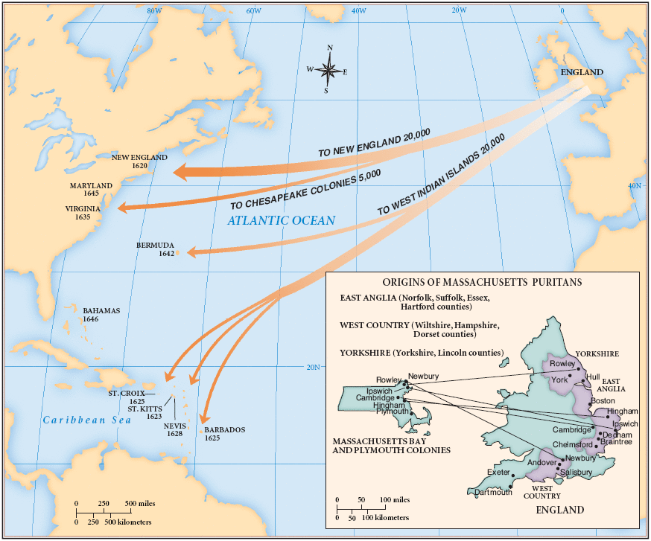
What type of source is this? (Primary or secondary and WHAT is it?) _________________________________
__________________________________________________________________________________________
How might puritans settle differently in Massachusetts versus Virginia?
__________________________________________________________________________________________
__________________________________________________________________________________________
__________________________________________________________________________________________
__________________________________________________________________________________________

Document 10

Environment, Disease, and Death in Virginia, 1618–1624 Early Virginia was a deadly place. Historians estimate that at least 28 percent of the population died each year, most of typhoid fever and dysentery (the “bloody flux”). Only a constant stream of migrants allowed the population of the colony to grow at all. Most settlers lived along the James River estuary during this period.

Zone of the James River Estuary | Population of Colony | Annual Mortality Rate | Proportion of all Deaths in Colony
Freshwater | 28.5% | 16.7% | 6.9%
Freshwater/Saltwater | 49.3% | 27.1% | 64.6%
Saltwater | 22.2% | 23.3% | 18.4%

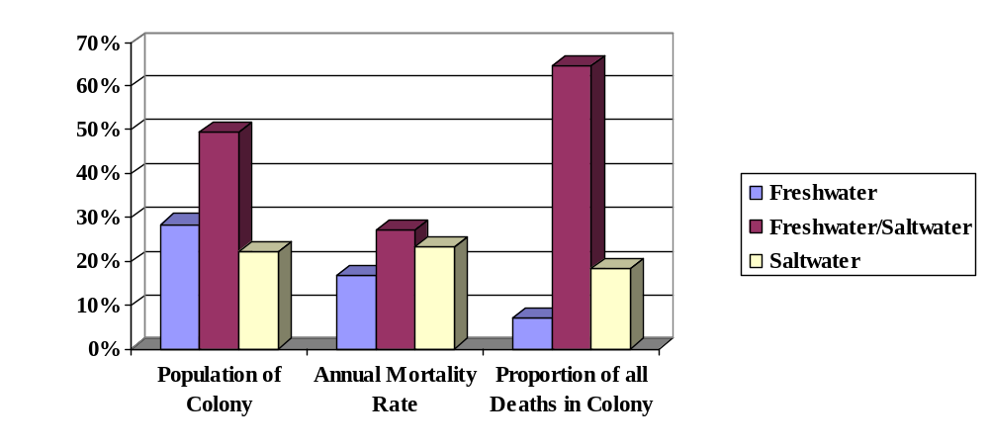
What type of source is this? (Primary or secondary and WHAT is it?) _________________________________
__________________________________________________________________________________________
What trends are evident from these figures and what might account for them? ___________________________
__________________________________________________________________________________________
__________________________________________________________________________________________
How might these trends affect the development of the Jamestown colony? ______________________________
__________________________________________________________________________________________
__________________________________________________________________________________________
__________________________________________________________________________________________

Document #11
Settlement Patterns in New England Towns, 1630–1700

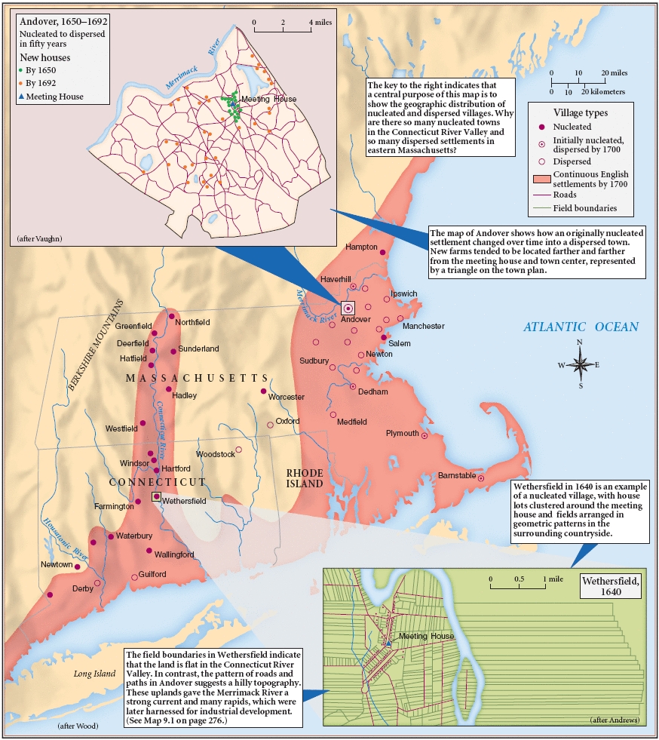

What type of source is this? (Primary or secondary and WHAT is it?) _________________________________
__________________________________________________________________________________________

What kind of economy does this map suggest might develop in this area? Why?
__________________________________________________________________________________________
__________________________________________________________________________________________
Document #12

River Plantations in Virginia, c. 1640 The first migrants settled in widely dispersed plantations—and different disease environments—along the James River.

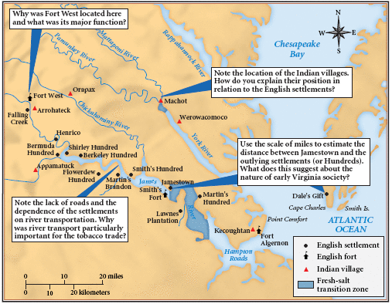

What type of source is this? (Primary or secondary and WHAT is it?) _________________________________
__________________________________________________________________________________________
What kind of economy does this map suggest might develop in this area? Why?
__________________________________________________________________________________________
__________________________________________________________________________________________
__________________________________________________________________________________________
__________________________________________________________________________________________
Essay Question: Although New England and the Chesapeake region were both settled largely by people of English origin, by 1700 the regions had evolved into two distinct societies. Why did this difference in development occur? Use the documents AND your knowledge of the colonial period up to 1700 to develop your answer.

Introduction Paragraph: Background- No more than two sentences. (What was going on at the time and the historical significance of the period-as it relates to the question)

_________________________________________________________________________________________
_________________________________________________________________________________________
_________________________________________________________________________________________
Main point #1- No more than one sentence.
_________________________________________________________________________________________
Main point #2- No more than one sentence.
_________________________________________________________________________________________
Main point #3- No more than one sentence.
_________________________________________________________________________________________
Thesis (must directly answer the question and tie the main points together)

_________________________________________________________________________________________
_________________________________________________________________________________________
_________________________________________________________________________________________

Body Paragraph #1
Topic sentence (Same as main point #1, limits paragraph to ONE idea and must directly support the thesis)
_________________________________________________________________________________________
_________________________________________________________________________________________
Evidence (specific person, law, treaty, development…)
_________________________________________________________________________________________
Evidence (specific person, law, treaty, development…)
_________________________________________________________________________________________
Evidence (specific person, law, treaty, development…)
_________________________________________________________________________________________
Transition (Connects to the next paragraph in a complex manner using a connecting sentence) _________________________________________________________________________________________

Body Paragraph #2
Topic sentence (Same as main point #2, limits paragraph to ONE idea and must directly support the thesis)
_________________________________________________________________________________________
_________________________________________________________________________________________
Evidence (specific person, law, treaty, development…)
_________________________________________________________________________________________
Evidence (specific person, law, treaty, development…)
_________________________________________________________________________________________
Evidence (specific person, law, treaty, development…)
_________________________________________________________________________________________
Transition (Connects to the next paragraph in a complex manner using a connecting sentence) _________________________________________________________________________________________

Body Paragraph #3
Topic sentence (Same as main point #3, limits paragraph to ONE idea and must directly support the thesis)
_________________________________________________________________________________________
_________________________________________________________________________________________
Evidence (specific person, law, treaty, development…)
_________________________________________________________________________________________
Evidence (specific person, law, treaty, development…)
_________________________________________________________________________________________
Evidence (specific person, law, treaty, development…)
_________________________________________________________________________________________
Transition (Connects to the next paragraph in a complex manner using a connecting sentence) _________________________________________________________________________________________

Conclusion paragraph
Very brief review of the essay. Sum it up in no more than two sentences.
_________________________________________________________________________________________
_________________________________________________________________________________________
Importance of the topic during its time
_________________________________________________________________________________________
_________________________________________________________________________________________
_________________________________________________________________________________________
_________________________________________________________________________________________
Long term historical importance of the topic
_________________________________________________________________________________________
_________________________________________________________________________________________
_________________________________________________________________________________________
_________________________________________________________________________________________

