Mr. Beckett
US History
Election of 1828

Overview
The election of 1828 between Andrew Jackson and John Quincy Adams set the standard for mudslinging during a campaign for higher office. Both politicians utilized personal slanders against the other in an attempt to win re-election (Adams), or victory and revenge for the 1824 election loss (Jackson). There are many parallels between this election and modern electoral campaign methodology.

Political Cartoons
Political cartoons is a method of expression that focuses on visualizations with writing as a supporting tool. See below. President Obama and Governor Romney playing twister trying to determine which states electoral votes will lead them to victory plays on the notion that some states matter, while others do not. How to become president, or re-elected as president, is based on a combination of unlikely suited states electoral votes. Trying to win those states is tricky, just like winning at twister. Funny.

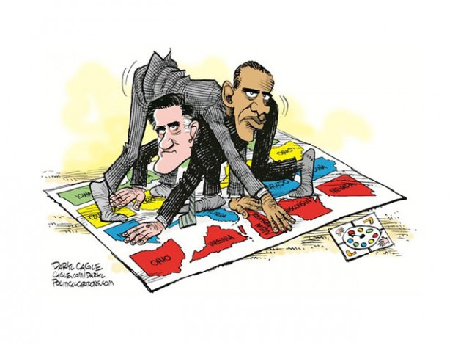

Assignment
Using your notes from the elections of 1824/28, create a hand-drawn political cartoon supporting one candidate while drawing upon the personal attacks that he made against the other. You may use captions, dialogue in your cartoon, but the focus should be on the visual element(s) of your cartoon.

Grading
This is a 10 point assignment broken into the following.

Use of relevant campaign slanders in your cartoon – 5 points
Visualization(s) that is/are relevant to the overall message in your cartoon – 5 points

