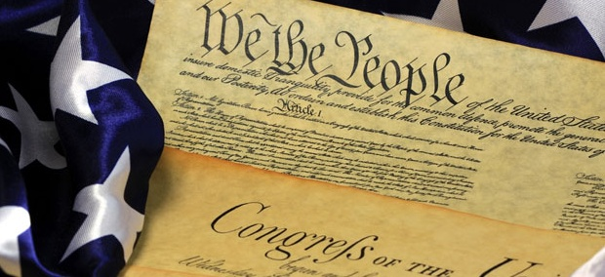

Mr. Beckett
US History
“We the People…” Project

Overview
Create a visual representation of the Preamble to the United States Constitution in the form of a tangible artistic project, non-digital in other words.

Purpose
To have a real world understanding of what the Preamble represents in today’s American society

Format
Pretty much, you can create any form of visual representation provided the words to the Preamble are present, and the visuals mesh with what the class understands the Preamble means.

Grading
This is a 25 point assignment, with the following breakdown:
5 Points – words of the Preamble are present
15 Points – words and visuals mesh
5 Points – organization and construction of project

Due Date
This project is due Tuesday, September 30 by the end of the class period.

We the people of the United States, in order to form a more perfect union, establish justice, insure domestic tranquility, provide for the common defense, promote the general welfare, and secure the blessings of liberty to ourselves and our posterity, do ordain and establish this Constitution for the United States of America.

